**Holstrom Experimental Protocol**

# Proposal Abstract

Limited availability of resources for competing physiological processes is an important constraint to plant fitness (growth and reproduction). The tradeoff between plant growth and chemical defense against herbivores is well-documented, with important implications for agricultural and forest management. Agroforestry breeding programs that select for tree varieties with superior growth may compromise the long-term sustainability of plantations if the consequences to herbivore defense are ignored. I propose to investigate this problem by assessing the relationship between tree growth and resistance to insect herbivore attack in an experimental plantation of aspen (*Populus tremuloides*). Twelve genotypes selected from each of fast-, moderate-, and slow-growing categories of aspen will be used to assess resistance to gypsy moths, an important outbreak defoliator. An insect performance study will measure the effects of genotype on metrics of herbivore fitness and an insect host selection study will measure herbivore choice between fast-, moderate-, and slow-growing genotypes. Foliar chemistry will be evaluated to determine the defense mechanism(s) underlying variation in insect performance and to assess growth-defense tradeoffs. This study will test a fundamental ecological hypothesis (plant vigor hypothesis) and provide insights into how to best design and manage forest plantations for productivity as well as long-term sustainability.

# Design Summary: This section meant to be a summarized overview of the project.

## Field Resistance Study Design:

* 12 WisAsp genotypes each from 3 vigor categories (fast, moderate, and slow growth; grouped according to growth since 2010), with 3 replicates (ramets) per genet, will be used for this experiment for a total of 108 ramets. (**Fig. 1; Table 1)**
* 10 freshly-molted 3rd instar gypsy moth caterpillars will be placed on each ramet for a total of 10 days
  + Larvae will be weighed immediately before and after the 10-day trials. Dead and missing larvae will also be counted in the field. (see larval deployment protocol)
* The experiment will run for a total of 13 days.
  + In the first 3 days, leaves will be collected for chemistry (and area measurements) and larvae will be placed on 36 trees per day, in the morning. Ten days after deployment, larvae will be counted and removed from the trees and leaves will be collected again. Leaves and larvae will then be taken to the lab for processing (see larval deployment protocol).
  + Pre-labeled trees will be approached according to WisAsp block.

## Lab Study Design:

* For each paired growth categories, (fast + med, fast + slow, med + slow) 12 petri dishes containing 2 4th instar caterpillars and 1 leaf from each growth category treatment (2 leaves total) will be placed in an incubator. Genets from each category will be selected randomly for each dish (without replacement).
* Additionally, 12 petri dishes containing 2 4th instar caterpillars and 1 leaf from each of 3 growth categories will be placed in an incubator. Genets from each category will be selected randomly for each dish (without replacement).
* Larvae will be weighed before (wet) and after (dry) the assays. Leaves will also be weighed before (wet) and after (dry). Standardization curves will be created for wet to dry mass conversion.

# Protocol:

## Larval Rearing: In order to obtain 3rd instar larvae for the field study, and 4th instar larvae for the choice assay, gypsy moth caterpillars will be reared from egg masses.

1. 12 days prior to deployment of larvae onto 36 trees, 6 egg mass will be placed in an incubator in a petri dish. 6 egg mass will be added to the incubator each day for a total of 3 days. Egg masses will hatch approximately 2 days after placement in the incubator.
2. The day after an egg mass was placed in the incubator, a small (approximately 0.5 cu.in.) amount of food will be added to the dish. The food will be changed every other day for 6 days after which a standardized diet of aspen leaves will be added to the dish.
3. Larvae will remain in the petri dish until their second molt, approximately 10 days (5 days to 1st molt, 5 days to 2nd). Leaves will be changed every 3 days or when they have been more than 75% consumed, whichever occurs first.
4. Larvae will be removed, during the molt, from the egg mass dish into a separate dish where they will be allowed to finish the molt. Groups of 10 newly molted larvae, of similar size, with empty guts will then be weighed and placed into 1 oz. plastic containers and labeled with the Tree ID of the tree onto which they will be placed at the next deployment event (within 12 hours). These containers will then be transferred to a separate incubator and kept at 10C, to slow metabolism until deployment. Once the plastic containers corresponding to 36 trees plus 5 additional backup containers have been filled and capped without food, any remaining 3rd instar larvae will either be allocated for another project, weighed and used to develop wet-mass to dry-mass standardization curves, or placed in a separate petri dish with leaves and allowed to continue development to 4th instar for choice assays. Leaves will be changed as in step 3.
5. Dishes containing 3rd instar larvae will be checked daily for 4th instar larvae following the same procedures from step 4 except 2 larvae will be placed directly into choice assay dishes with leaves according to treatment. Larvae used for choice assays will be fed on a standardized aspen diet for 4 to 5 days prior to assays for the purposes of acclimating the larvae to an aspen diet.
6. Once all larvae in a dish have molted to 3rd instar, died, or at the end of all studies requiring GM: remove petri dishes from incubator freeze the dishes for 48 hours, and clean them thoroughly.

## Larval Deployment: Once sufficient numbers of larvae have reached 3rd instar, larval deployment will commence. Larvae will be deployed on 36 trees each day, over the course of 3 days, for a total of 108 trees. Prior to deployment, experimental trees will be labeled with brightly colored flagging tape and will be approached by WisAsp block (**Figure 2)**.

1. In the morning before proceeding to the field, remove the 16 plastic containers containing 10 larvae each from the incubator and move them to a digital balance with weigh trays and insect forceps.
2. place plastic weighing tray on the balance and tare the balance. Then empty the larvae onto the tray and record their weight, *en masse* to the nearest mg.
3. Ensure that the container the larvae were removed from still has a twist-tie secured with no holes in the container large enough for the larvae to escape through. If the twist-tie is no longer secure, or a large hole is present, replace the container with a new one. Place the larvae in the container, seal the container, and mark the container (sharpie) with the Tree ID and Serial #. corresponding to the data sheet row in which larval mass was entered. Mark extra 5 containers with letters A-E (corresponding to data sheet ID)
4. Double-check that the cap is secured on the weighed and marked containers and place them into shallow boxes in an empty cooler for transport to WisAsp.
5. Before deploying the larvae onto a tree, haphazardly collect 10 leaves, without petioles, from the lower half of the canopy in the NE quadrant of the tree and place them into a coin envelope pre-labeled with Serial number and tree ID. Store the envelopes in a waterproof bag submerged in ice (in a cooler) for transport back to the lab.
6. To deploy a container corresponding to a tree, place a mesh bag over a branch (previously selected from the NE quadrant at breast height) and crimp one end of the bag tightly around the branch, making sure that extra material is gathered into the tie and that no holes are present. This can be done with twist-ties or releasable zip-ties. Next, attach the container to the branch within the bag, (using the twist-tie attached to the container) and open the lid, ensuring that no larvae can fall out of the bag before it is closed. Quickly seal the second end of the bag using the same methods as before.
7. Place a second bag over the first bag using the same methods to seal both ends.
8. Repeat steps 6 and 7, without larvae, on the control branch (previously selected in the NE quadrant and just above and adjacent to the experimental branch)
9. Record the date, time, and any notes or comments about the tree, deployment process, use of backup larvae, etc.

## Larval Collection: After the larvae have been allowed to feed on their branch for 10 days, they must be removed and weighed. They will be weighed immediately after collection and again after freezing and oven drying (60C).

1. After deploying larvae for the day (if applicable), proceed to trees on which larvae were deployed 10 days earlier.
2. Carefully remove the outer bag from the branch. Check this bag for larvae, take note if any are found and add them to the collected larvae container corresponding to the correct tree.
3. Shake the branch vigorously to detach larvae into the inner bag. Check for any larvae still remaining on leaves or branches. Carefully remove the inner bag from the branch, being sure not to spill any dead or fallen larvae. Search for and collect any larvae remaining on the branches (for a total of 10) and place them into the bag. Seal the bag at both ends and return to the lab for processing. Keep in ice chest with cold packets.
4. After removing the larvae, record the date, time, and then haphazardly collect 10 leaves from the branch on which caterpillars were located and another 10 from the control branch. Place leaves into separate envelopes (local and control), store in water piks in water-proof bags on ice for transport back to the lab.
5. Detach plastic cup from branch, record any other comments.
6. Return insect to the lab and place into refrigerator (not freezer) while processing leaves (below). .

## Leaf Processing: Upon return to the lab, leaves collected need to be scanned for area and freeze-dried for chemistry.

1. Empty leaves from envelope onto leaf-scanner one-by-one, ensuring that the margins of the leaves are within the boundaries of the scanner. Record the number of leaves and the total area on the datasheet corresponding to the correct tree (initial area if 1st collection, second area local/systemic if 2nd collection). Also mark these values directly onto the envelope and return the leaves to the envelope for freeze-drying
2. Place envelopes of leaves into a bundle of no more than 7 packets and attach them with an alligator clip on one end.
3. Place bundles into freeze dryer and let them run for 48 hours. This can be done concurrently with larval drying (see larval processing)
4. Once dried, leaves will be weighed and ground into powder for chemical analysis

## Larval Processing: Once larvae have been collected from the trees, they will be weighed, dried, and weighed again.

1. Count live larvae, dead larvae and compare this to the start number (10). Record these counts.
2. Weigh larvae individually following step 2 of larval deployment protocol and record their weights.
3. Place larvae into container and freeze them for at least 24hours. Then remove from the freezer, place them in a plastic container (with holes) or shell vials and oven-dry them for 48 hours
4. After oven-drying, larval dry weights will be recorded in the same way as wet weights.

Choice Assay: A choice study will be conducted to determine if larvae prefer fast, moderate, or slow growing aspen

1. Collect 1 short shoot (rosette) of leaves from one ramet of each genet (haphazardly selected) of this study from WisAsp and place them into water picks labeled with Genet and Serial No. Place the water piks into a Ziploc bag.
2. Scan and record the leaf area of 3 leaves, with petioles, from every individual rosette according to leaf processing protocol. Then place the leaves individually into their own water piks (converted 2 ml microfuge tubes), appropriately labeled. The remaining leaves will be used to create wet to dry mass calibrations (weighed, oven-dried, weighed again).
3. Prepare 36 petri dishes (15cm diameter) for paired assays according to **Table 2** and 12 petri dishes for tripled assays according to **Table 3** and label dishes with treatment type, and the genets and tree IDs of the leaves.
4. Record initial weights of 2 larvae for each dish, place the larvae into their respective dishes. Record the start time and date for each assay and allow larvae to feed for 3 days.
5. After 2 days of feeding, remove the larvae, record the date and time, weigh them (wet + dry according to larval processing).
6. Re-scan and record the area for each leaf (the difference between initial and final leaf area is equal to area consumed).
7. Weigh the leaves, oven-dry them, and then weigh them again as per above protocol.
8. Clean petri dishes.

# Figures and Tables

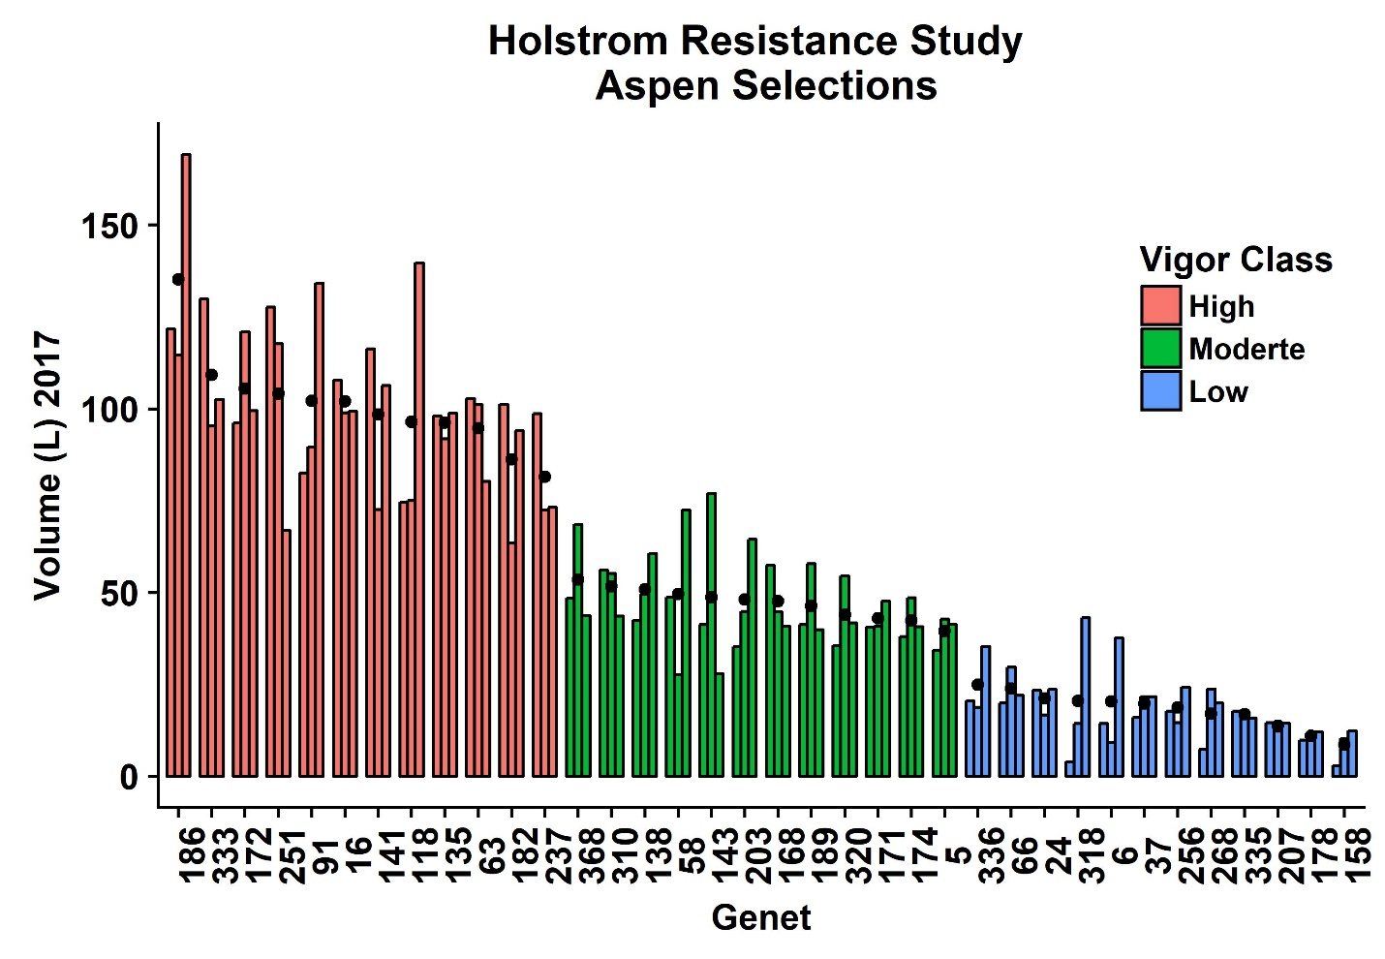

**Figure 1**: 17-Year average growth of Aspen selected for this study. Individual bars represent ramets and groups of 3 bars represent a genet (x axis). Black dots represent the Genotype mean (n = 3) and colors represent vigor class.

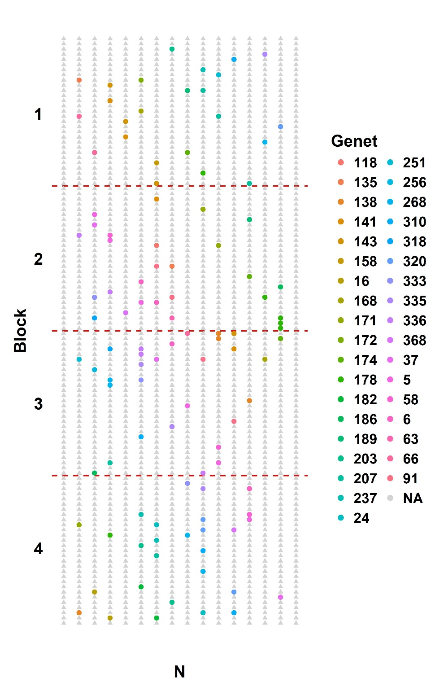

**Figure 2**: Map of WisAsp and the location of Resistance study experimental ramets. Colored circles represent the experimental trees (colored by genet) and grey triangles represent non-experimental trees. Red lines delineate WisAsp blocks and North is oriented down.

***Table 1:*** *Selected Individuals:*

|  |  |  |  |  |  |  |
| --- | --- | --- | --- | --- | --- | --- |
| **Genet** | **Serial Number** | **Tree Location** | **Vigor Category** | **Volume 2017 (L)** | **PG (%) June 2016** | **CT (%) June 2016** |
| 118 | 1127 | 3_M_7 | fast | 74.50 | 11.70 | 2.52 |
| 118 | 2 | 1_A_2 | fast | 75.05 | 9.84 | 4.27 |
| 118 | 650 | 2_J_6 | fast | 139.72 | 9.69 | 3.27 |
| 16 | 213 | 1_H_17 | fast | 98.85 | 4.59 | 9.42 |
| 16 | 683 | 2_K_11 | fast | 99.41 | 5.83 | 8.43 |
| 16 | 1114 | 3_L_22 | fast | 107.89 | 6.72 | 8.28 |
| 91 | 1190 | 4_A_14 | fast | 82.57 | 3.73 | 8.49 |
| 91 | 242 | 1_I_18 | fast | 89.67 | 4.72 | 9.11 |
| 91 | 555 | 2_F_23 | fast | 134.21 | 4.16 | 10.06 |
| 141 | 226 | 1_I_2 | fast | 72.64 | 3.94 | 14.44 |
| 141 | 959 | 3_G_7 | fast | 106.34 | 5.05 | 11.08 |
| 141 | 1270 | 4_D_10 | fast | 116.34 | 10.91 | 9.08 |
| 333 | 671 | 2_J_27 | fast | 95.26 | 3.24 | 4.21 |
| 333 | 858 | 3_C_18 | fast | 102.45 | 4.47 | 9.63 |
| 333 | 244 | 1_I_20 | fast | 129.92 | 4.94 | 7.66 |
| 251 | 859 | 3_C_19 | fast | 66.87 | 1.59 | 11.72 |
| 251 | 526 | 2_E_22 | fast | 117.74 | 2.46 | 11.10 |
| 251 | 250 | 1_I_26 | fast | 127.71 | 1.30 | 10.37 |
| 63 | 941 | 3_F_17 | fast | 80.29 | 6.41 | 6.68 |
| 63 | 512 | 2_E_8 | fast | 101.12 | 5.35 | 5.68 |
| 63 | 328 | 1_L_20 | fast | 102.77 | 7.01 | 6.17 |
| 135 | 700 | 2_K_28 | fast | 91.79 | 5.34 | 9.06 |
| 135 | 329 | 1_L_21 | fast | 98.13 | 4.83 | 8.23 |
| 135 | 930 | 3_F_6 | fast | 98.82 | 3.15 | 7.50 |
| 182 | 751 | 2_M_23 | fast | 63.53 | 6.16 | 7.29 |
| 182 | 815 | 3_B_3 | fast | 94.04 | 7.14 | 6.91 |
| 182 | 334 | 1_L_26 | fast | 101.24 | 7.54 | 6.40 |
| 237 | 369 | 1_N_5 | fast | 72.50 | 8.11 | 12.00 |
| 237 | 937 | 3_F_13 | fast | 73.20 | 7.73 | 10.93 |
| 237 | 1273 | 4_D_13 | fast | 98.70 | 7.99 | 10.47 |
| 186 | 467 | 2_C_19 | fast | 114.64 | 9.95 | 9.17 |
| 186 | 466 | 2_C_18 | fast | 121.73 | 8.54 | 7.14 |
| 186 | 835 | 3_B_23 | fast | 169.20 | 6.29 | 6.33 |
| 172 | 1371 | 4_G_27 | fast | 96.10 | 2.40 | 11.52 |
| 172 | 872 | 3_D_4 | fast | 99.51 | 1.07 | 7.26 |
| 172 | 523 | 2_E_19 | fast | 120.98 | 2.59 | 10.16 |
| 320 | 1442 | 4_J_14 | med | 35.54 | 4.96 | 6.55 |
| 320 | 819 | 3_B_7 | med | 41.69 | 6.84 | 9.51 |
| 320 | 57 | 1_C_1 | med | 54.50 | 8.17 | 8.71 |
| 174 | 1211 | 4_B_7 | med | 38.04 | 2.98 | 10.57 |
| 174 | 73 | 1_C_17 | med | 40.65 | 2.75 | 15.55 |
| 174 | 697 | 2_K_25 | med | 48.56 | 4.58 | 12.33 |
| 168 | 473 | 2_C_25 | med | 40.82 | 8.55 | 5.06 |
| 168 | 1303 | 4_E_15 | med | 44.78 | 4.69 | 8.48 |
| 168 | 127 | 1_E_15 | med | 57.44 | 3.93 | 9.32 |
| 58 | 441 | 2_B_21 | med | 27.73 | 8.81 | 8.24 |
| 58 | 159 | 1_F_19 | med | 48.69 | 7.64 | 5.02 |
| 58 | 902 | 3_E_6 | med | 72.45 | 4.94 | 10.28 |
| 368 | 672 | 2_J_28 | med | 43.71 | 14.62 | 3.92 |
| 368 | 1053 | 3_J_17 | med | 48.44 | 12.84 | 3.00 |
| 368 | 172 | 1_G_4 | med | 68.54 | 15.48 | 5.70 |
| 138 | 1149 | 3_N_1 | med | 42.40 | 6.98 | 8.82 |
| 138 | 282 | 1_K_2 | med | 49.53 | 4.81 | 10.00 |
| 138 | 529 | 2_E_25 | med | 60.62 | 5.29 | 9.85 |
| 203 | 1197 | 4_A_21 | med | 35.19 | 2.00 | 8.94 |
| 203 | 286 | 1_K_6 | med | 44.87 | 5.23 | 7.19 |
| 203 | 639 | 2_I_23 | med | 64.42 | 4.86 | 9.00 |
| 171 | 1252 | 4_C_20 | med | 40.60 | 3.69 | 14.09 |
| 171 | 415 | 2_A_23 | med | 40.85 | 3.89 | 11.04 |
| 171 | 955 | 3_G_3 | med | 47.71 | 2.65 | 12.94 |
| 310 | 570 | 2_G_10 | med | 43.64 | 3.14 | 11.79 |
| 310 | 1403 | 4_I_3 | med | 55.17 | 3.15 | 13.75 |
| 310 | 1157 | 3_N_9 | med | 56.17 | 3.57 | 11.34 |
| 5 | 1317 | 4_F_1 | med | 34.33 | 5.57 | 13.70 |
| 5 | 950 | 3_F_26 | med | 41.41 | 3.88 | 14.02 |
| 5 | 586 | 2_G_26 | med | 42.73 | 2.58 | 12.13 |
| 143 | 965 | 3_G_13 | med | 27.89 | 10.23 | 6.54 |
| 143 | 1309 | 4_E_21 | med | 41.22 | 16.99 | 8.75 |
| 143 | 617 | 2_I_1 | med | 76.98 | 10.51 | 6.31 |
| 189 | 906 | 3_E_10 | med | 39.93 | 5.77 | 9.13 |
| 189 | 1450 | 4_J_22 | med | 41.26 | 5.09 | 9.38 |
| 189 | 715 | 2_L_15 | med | 57.87 | 5.52 | 8.63 |
| 335 | 19 | 1_A_19 | slow | 15.88 | 4.32 | 7.53 |
| 335 | 1485 | 4_L_1 | slow | 16.99 | 5.85 | 11.19 |
| 335 | 1103 | 3_L_11 | slow | 17.76 | 4.46 | 8.17 |
| 318 | 1321 | 4_F_5 | slow | 3.89 | 6.92 | 18.48 |
| 318 | 34 | 1_B_6 | slow | 14.42 | 4.59 | 14.95 |
| 318 | 421 | 2_B_1 | slow | 43.10 | 3.80 | 10.61 |
| 268 | 1151 | 3_N_3 | slow | 7.31 | 11.98 | 4.76 |
| 268 | 1379 | 4_H_7 | slow | 19.95 | 10.49 | 5.96 |
| 268 | 133 | 1_E_21 | slow | 23.78 | 8.38 | 5.79 |
| 158 | 119 | 1_E_7 | slow | 2.93 | 10.23 | 8.32 |
| 158 | 1552 | 4_N_12 | slow | 10.36 | 9.79 | 6.20 |
| 158 | 528 | 2_E_24 | slow | 12.36 | 9.47 | 7.89 |
| 207 | 1521 | 4_M_9 | slow | 12.26 | 9.64 | 8.93 |
| 207 | 783 | 2_N_27 | slow | 14.45 | 5.29 | 8.76 |
| 207 | 141 | 1_F_1 | slow | 14.65 | 6.98 | 6.07 |
| 66 | 1032 | 3_I_24 | slow | 19.91 | 7.47 | 8.33 |
| 66 | 647 | 2_J_3 | slow | 22.04 | 6.02 | 8.21 |
| 66 | 153 | 1_F_13 | slow | 29.73 | 5.87 | 7.96 |
| 6 | 156 | 1_F_16 | slow | 9.31 | 4.49 | 10.29 |
| 6 | 1249 | 4_C_17 | slow | 14.36 | 2.86 | 9.60 |
| 6 | 602 | 2_H_14 | slow | 37.64 | 2.59 | 13.76 |
| 336 | 223 | 1_H_27 | slow | 18.81 | 2.55 | 14.19 |
| 336 | 1150 | 3_N_2 | slow | 20.53 | 1.91 | 18.03 |
| 336 | 451 | 2_C_3 | slow | 35.39 | 1.50 | 14.94 |
| 256 | 234 | 1_I_10 | slow | 14.62 | 4.25 | 10.26 |
| 256 | 1391 | 4_H_19 | slow | 17.68 | 5.57 | 11.76 |
| 256 | 616 | 2_H_28 | slow | 24.19 | 4.32 | 10.96 |
| 178 | 1423 | 4_I_23 | slow | 9.80 | 4.74 | 14.79 |
| 178 | 238 | 1_I_14 | slow | 10.98 | 6.22 | 13.38 |
| 178 | 833 | 3_B_21 | slow | 12.06 | 6.66 | 13.93 |
| 37 | 1538 | 4_M_26 | slow | 15.99 | 6.89 | 12.48 |
| 37 | 298 | 1_K_18 | slow | 21.64 | 9.42 | 10.44 |
| 37 | 848 | 3_C_8 | slow | 21.70 | 7.45 | 14.05 |
| 24 | 1481 | 4_K_25 | slow | 16.66 | 4.75 | 18.39 |
| 24 | 1419 | 4_I_19 | slow | 23.41 | 4.54 | 15.22 |
| 24 | 803 | 3_A_19 | slow | 23.60 | 4.05 | 17.75 |

***Table 2:*** *Choice Assay Pairs*

|  |  |  |
| --- | --- | --- |
| **Treatment** | **Genet 1** | **Genet 2** |
| fast + med | 135 | 203 |
| fast + slow | 91 | 268 |
| med + slow | 171 | 178 |
| fast + med | 186 | 368 |
| fast + slow | 251 | 6 |
| med + slow | 168 | 335 |
| fast + med | 118 | 189 |
| fast + slow | 91 | 66 |
| med + slow | 189 | 178 |
| fast + med | 118 | 310 |
| fast + slow | 182 | 268 |
| med + slow | 174 | 37 |
| fast + med | 186 | 310 |
| fast + slow | 135 | 66 |
| med + slow | 203 | 335 |
| fast + med | 333 | 138 |
| fast + slow | 141 | 256 |
| med + slow | 5 | 158 |
| fast + med | 16 | 143 |
| fast + slow | 237 | 256 |
| med + slow | 171 | 24 |
| fast + med | 172 | 168 |
| fast + slow | 172 | 207 |
| med + slow | 58 | 24 |
| fast + med | 63 | 5 |
| fast + slow | 141 | 207 |
| med + slow | 138 | 158 |
| fast + med | 333 | 320 |
| fast + slow | 182 | 6 |
| med + slow | 143 | 336 |
| fast + med | 16 | 320 |
| fast + slow | 251 | 318 |
| med + slow | 368 | 336 |
| fast + med | 237 | 58 |
| fast + slow | 63 | 37 |
| med + slow | 174 | 318 |

***Table 3:*** *Choice Assay Triples*

|  |  |  |  |
| --- | --- | --- | --- |
| **Treatment** | **Genet 1** | **Genet 2** | **Genet 3** |
| fast + med + slow | 186 | 58 | 158 |
| fast + med + slow | 135 | 5 | 268 |
| fast + med + slow | 333 | 174 | 37 |
| fast + med + slow | 237 | 368 | 66 |
| fast + med + slow | 251 | 168 | 336 |
| fast + med + slow | 141 | 203 | 207 |
| fast + med + slow | 172 | 138 | 318 |
| fast + med + slow | 182 | 171 | 256 |
| fast + med + slow | 91 | 143 | 178 |
| fast + med + slow | 63 | 189 | 6 |
| fast + med + slow | 16 | 320 | 24 |
| fast + med + slow | 118 | 310 | 335 |